Exprement 2 : Write Python programing to solve 8- Queen problemAim
To solve the 8-Queen problem using Python and place 8 queens on an 8×8 chessboard such that no two queens attack each other.
Algorithm
- Start with an empty 8×8 chessboard.
- Place a queen in the first row.
- Check whether the position is safe:
  - No queen in the same column.
  - No queen in the same diagonal.
- If safe, place the queen and move to the next row.
- If no safe position is found, backtrack and try another position.
- Repeat until all 8 queens are placed.
Program
N = 8
board = [-1] * N
def safe(row, col):
for i in range(row):
if board[i] == col or abs(board[i] - col) == abs(i - row):
return False
return True
def solve(row):
if row == N:
for i in range(N):
for j in range(N):
if board[i] == j:
print("Q", end=" ")
else:
print(".", end=" ")
print()
return True
for col in range(N):
if safe(row, col):
board[row] = col
if solve(row + 1):
return True
return False
solve(0)
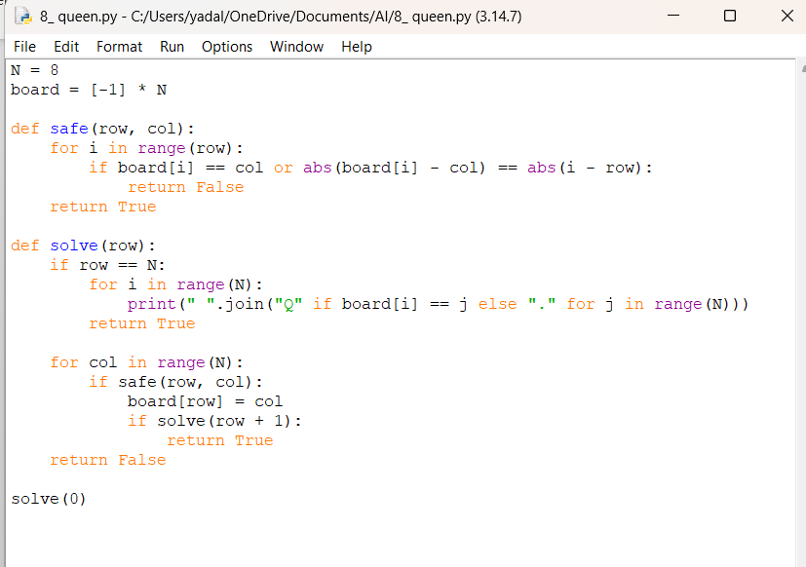
Output
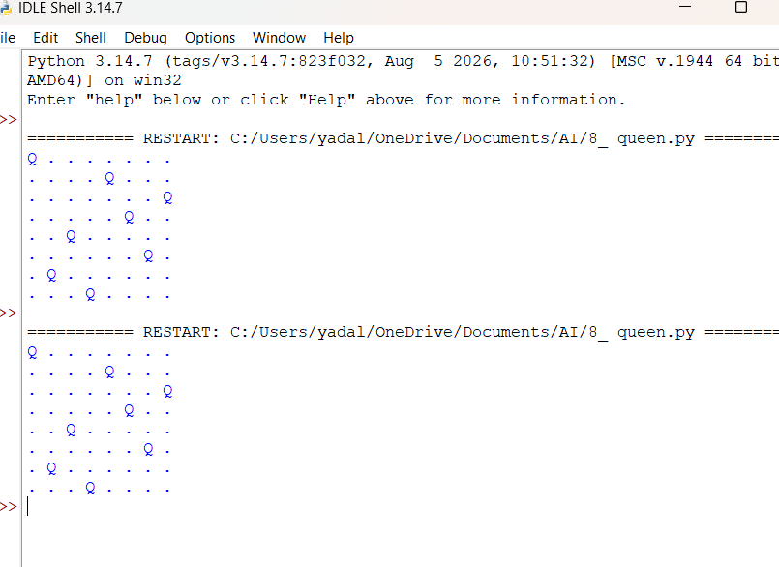
Result
The 8-Queen problem was successfully solved using the backtracking technique in Python, and all 8 queens were placed on the chessboard without attacking each other.

